> sirh <- function(time, stocks, auxs){
+ with(as.list(c(stocks, auxs)),{
+ N <- 10000 # Eq (31)
+ IR <- beta*I*S/N*M # Eq (22)
+ VR <- v*S # Eq (23)
+ AR <- hf*gamma*I # Eq (24)
+ RR <- (1-hf)*gamma*I # Eq (25)
+ DR <- d*H # Eq (26)
+
+ dS_dt <- -IR -VR # Eq (17)
+ dI_dt <- IR - AR - RR # Eq (18)
+ dH_dt <- AR - DR # Eq (19)
+ dR_dt <- RR + DR + VR # Eq (20)
+ dM_dt <- (M_min - M) *
+ alpha # Eq (21)
+ return (list(c(dS_dt,dI_dt,dH_dt,dR_dt,dM_dt),
+ Beta=beta,
+ Gamma=gamma,
+ HF=hf,
+ V=v,
+ Alpha=alpha,
+ M_Min=M_min,
+ Infections=IR,
+ Recovering=RR,
+ Vaccinated=VR,
+ Hospitalised=AR,
+ Discharged=DR,
+ CheckSum=S + I + R + H))
+ })
+ }
> run_scenario <- function(run_id=1,
+ stocks=c(S=9999, # Eq (34)
+ I=1, # Eq (35)
+ H=0, # Eq (36)
+ R=0, # Eq (37)
+ M=1 # Eq (38)
+ ),
+ simtime=seq(0,50,by=0.25),
+ beta=1, # Eq (27)
+ gamma=0.25, # Eq (28)
+ alpha=0.5, # Eq (23)
+ M_min=0.3, # Eq (39)
+ d=0.1, # Eq (32)
+ hf=0.1, # Eq (30)
+ v=0.1 # Eq (29)
+ ){
+ auxs <- c(beta=beta,
+ gamma=gamma,
+ alpha=alpha,
+ M_min=M_min,
+ d=d,
+ hf=hf,
+ v=v)
+
+ res <- ode(y=stocks,
+ times=simtime,
+ func = sirh,
+ parms=auxs,
+ method="euler") %>%
+ data.frame() %>%
+ dplyr::as_tibble() %>%
+ dplyr::mutate(RunID=as.integer(run_id)) %>%
+ dplyr::select(RunID, everything())
+ }
> alpha_vals <- seq(0,.20,length.out=50)
> vacc_vals <- seq(0,0.05,length.out=50)
> sim_inputs <- expand.grid(alpha_vals,vacc_vals)
> summary(sim_inputs)
Var1 Var2
Min. :0.00000 Min. :0.00000
1st Qu.:0.04898 1st Qu.:0.01224
Median :0.10000 Median :0.02500
Mean :0.10000 Mean :0.02500
3rd Qu.:0.15102 3rd Qu.:0.03776
Max. :0.20000 Max. :0.05000
> run_id <- 1
>
> sim_res <- map2(sim_inputs[,1],
+ sim_inputs[,2],~{
+ res <- run_scenario(run_id = run_id,
+ alpha = .x,
+ v = .y,
+ simtime = seq(0,75,by=0.25),
+ hf = 0.10)
+ run_id <<- run_id + 1
+ res
+ }) %>% dplyr::bind_rows()
> sim_res
# A tibble: 752,500 × 19
RunID time S I H R M Beta Gamma HF V
<int> <dbl> <dbl> <dbl> <dbl> <dbl> <dbl> <dbl> <dbl> <dbl> <dbl>
1 1 0 9999 1 0 0 1 1 0.25 0.1 0
2 1 0.25 9999. 1.19 0.00625 0.0562 1 1 0.25 0.1 0
3 1 0.5 9998. 1.41 0.0135 0.123 1 1 0.25 0.1 0
4 1 0.75 9998. 1.67 0.0220 0.203 1 1 0.25 0.1 0
5 1 1 9998. 1.99 0.0319 0.298 1 1 0.25 0.1 0
6 1 1.25 9997. 2.36 0.0435 0.410 1 1 0.25 0.1 0
7 1 1.5 9997. 2.80 0.0572 0.544 1 1 0.25 0.1 0
8 1 1.75 9996. 3.33 0.0733 0.703 1 1 0.25 0.1 0
9 1 2 9995. 3.95 0.0923 0.892 1 1 0.25 0.1 0
10 1 2.25 9994. 4.69 0.115 1.12 1 1 0.25 0.1 0
# ℹ 752,490 more rows
# ℹ 8 more variables: Alpha <dbl>, M_Min <dbl>, Infections <dbl>,
# Recovering <dbl>, Vaccinated <dbl>, Hospitalised <dbl>,
# Discharged <dbl>, CheckSum <dbl>
# ℹ Use `print(n = ...)` to see more rows
> time_h <- sim_res %>%
+ dplyr::group_by(time) %>%
+ dplyr::summarize(MeanH=mean(H),
+ Q95=quantile(H,0.95),
+ Q05=quantile(H,0.05))
> time_h
# A tibble: 301 × 4
time MeanH Q95 Q05
<dbl> <dbl> <dbl> <dbl>
1 0 0 0 0
2 0.25 0.00625 0.00625 0.00625
3 0.5 0.0135 0.0135 0.0135
4 0.75 0.0219 0.0220 0.0219
5 1 0.0317 0.0319 0.0316
6 1.25 0.0430 0.0434 0.0426
7 1.5 0.0560 0.0569 0.0551
8 1.75 0.0709 0.0726 0.0692
9 2 0.0880 0.0911 0.0851
10 2.25 0.107 0.113 0.103
# ℹ 291 more rows
# ℹ Use `print(n = ...)` to see more rows
> p3 <- ggplot(sim_res,aes(x=time,y=Infections,color=RunID,group=RunID))+
+ geom_line()+
+ scale_color_gradientn(colors=rainbow(14))+
+ theme(legend.position = "none")+
+ labs(title="Infections (flow)")+
+ theme(title = element_text(size=9))

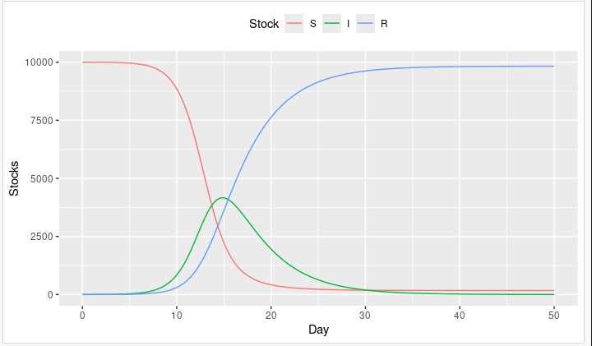

> p4 <- ggplot(sim_res,aes(x=time,y=H,color=RunID,group=RunID))+
+ geom_line()+
+ scale_color_gradientn(colors=rainbow(14))+
+ theme(legend.position = "none")+
+ labs(title="People in hospital (stock)")+
+ theme(title = element_text(size=9))

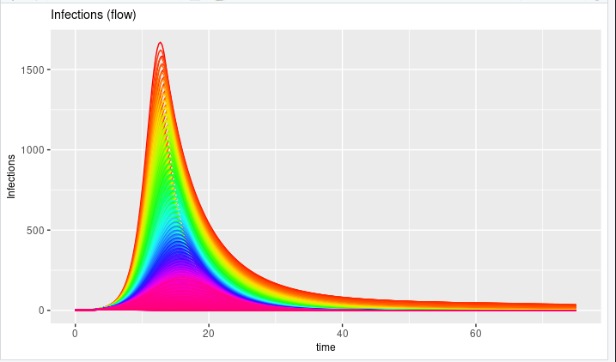

> p5 <- ggplot(time_h,aes(x=time,y=MeanH))+geom_line()+
+ geom_ribbon(aes(x=time,ymin=Q05,ymax=Q95),
+ alpha=0.4,fill="steelblue2")+
+ labs(title="90% quantiles for people in hospital")+
+ theme(title = element_text(size=9))
> p5

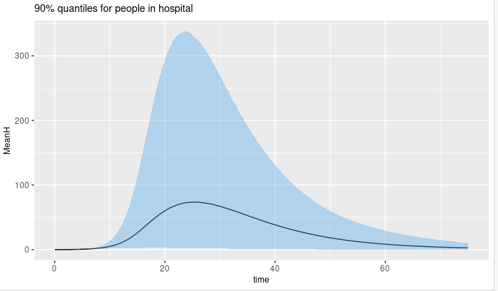
> g2 <- ggarrange(p3,p4,p5,nrow = 3)
> g2

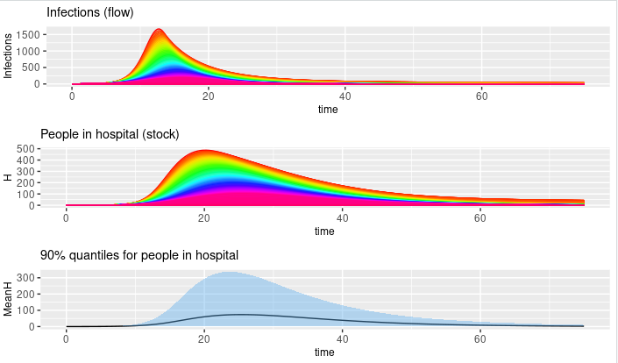
> max_h <- sim_res %>%
+ dplyr::group_by(RunID) %>%
+ dplyr::summarize(MH=max(H),
+ V=first(V),
+ Alpha=first(Alpha))
> p6 <- ggplot(max_h,aes(x=Alpha,y=V,color=MH,size=MH))+geom_point()+
+ scale_color_gradient(low="blue", high="red")+
+ theme(legend.position = "none")+
+ labs(title=paste0("Parameter Analysis"))+
+ labs(subtitle=paste0("Max peak = ",
+ round(max(max_h$MH),0),
+ " at point (0,0)"))+
+ theme(title = element_text(size=9))
> p6

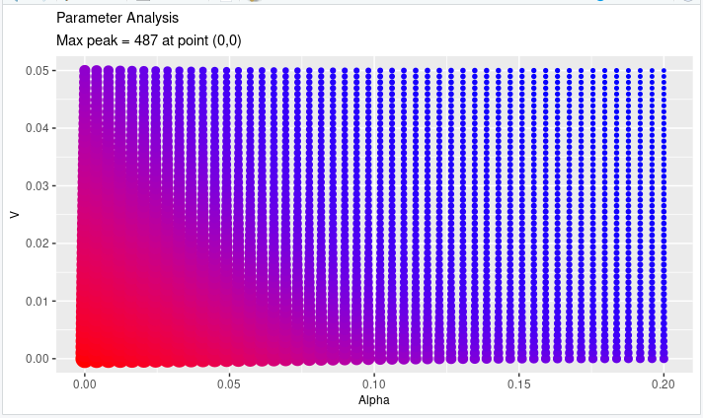

> p7 <- ggplot(max_h,aes(x=Alpha,y=V,z=MH))+geom_contour_filled()+
+ theme(legend.position = "none")+
+ labs(title=paste0("Contour plot"))+
+ labs(subtitle=paste0("Yellow band range (450,500]"))+
+ theme(title = element_text(size=9))
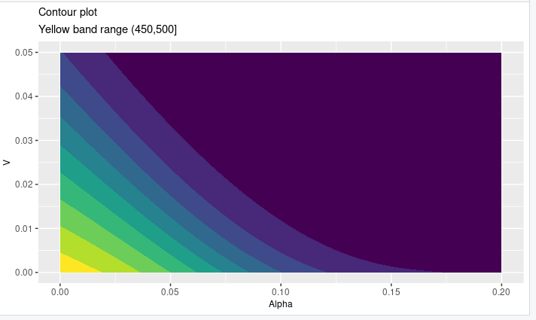

> g3 <- ggarrange(p6,p7,nrow = 1)
> g3

